CTM-I Use Case

Trade Correction

Version 0.1

Use Case Name | Trade Correction
Actor | Broker, Firm User, Market Ops, Ops, App Support
Pre-conditions /Assumptions | User has selected to edit the trade from the Trade Message Browse use case
Post Conditions | User can select to return to the Trade Message Browse screen by clicking on the “Return to Message screen” link.
Screenshot | 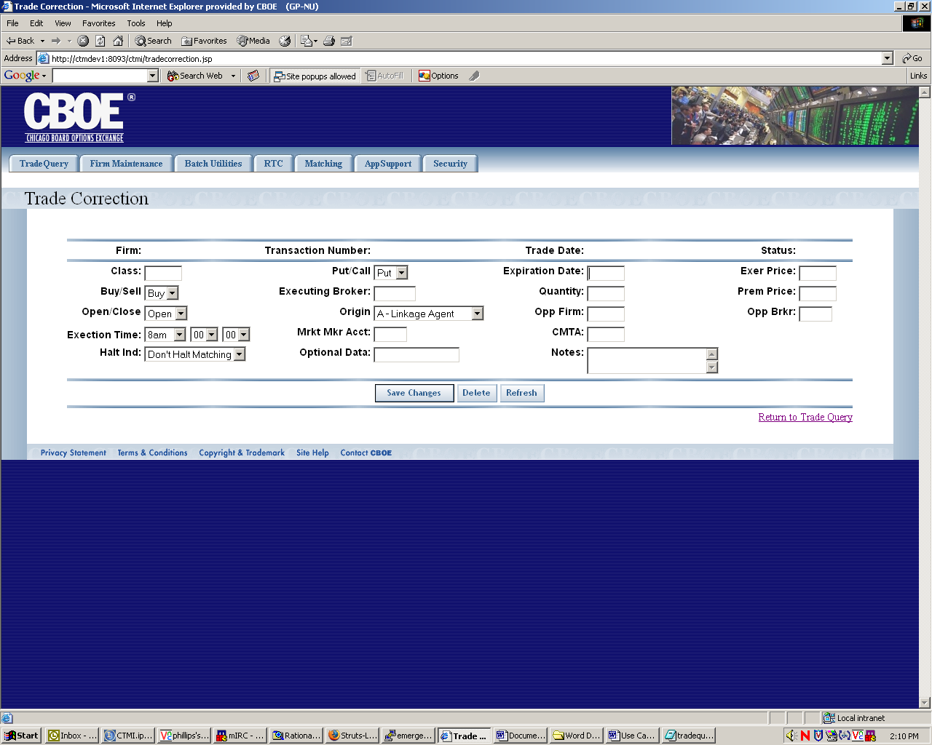
Flow of Events | - A request is sent to CTM-R to get the specific trades information to display  - Trade Correction screen appears.  - The fields will be pre-populated from the selection of the previous screen.  - User can change the following data fields  - Class  - Put/Call will be limited to “Put” or “Call”.  - Expiration Date  - Exercise Price  - Buy/Sell will be limited to “Buy” or “Sell”.  - Executing Broker  - Quantity  - Premium Price  - Open/Close will be limited to “Blank”, “Open” and “Close”.  - Origin will be limited to  “A – Linkage Agent”  “B – Broker Dealer”  “C – Customer”  “F – Firm”  “J – Joint BackOffice”  “M – Market Maker”  “N- Non-Market Maker”  “P – Linkage Account”  “S – Stock Specialist”  “Z – Other Non Raes”  - Opposite Firm  - Opposite Broker  - Execution Time will be limited to  Hour “8 am to 4 pm”  Minutes & Seconds “00 to 59”  - Market Maker Account  - CMTA  - Halt Indication will be limited to “Blank” and “H”  - Optional Data  - Notes  - Link either the “Message Screen” or “Trade Query Screen” depending on where the user came from will allow user to return to these screens. User will see the same critia data when going back to the screen they came from  - “Save” function will send the data to CTM-R for validation and return with errors or safe store the data.  - “Delete” function will allow the user to delete the trade. A pop-up screen will ask the user if they are sure of this action.  - “Refresh” function will re-populate the data as it was prior to changes made on the screen
Alternative Path | - If the trade being corrected is in a status of “Error”, the fields that are in error will be highlighted.

